NCBI ORF finder
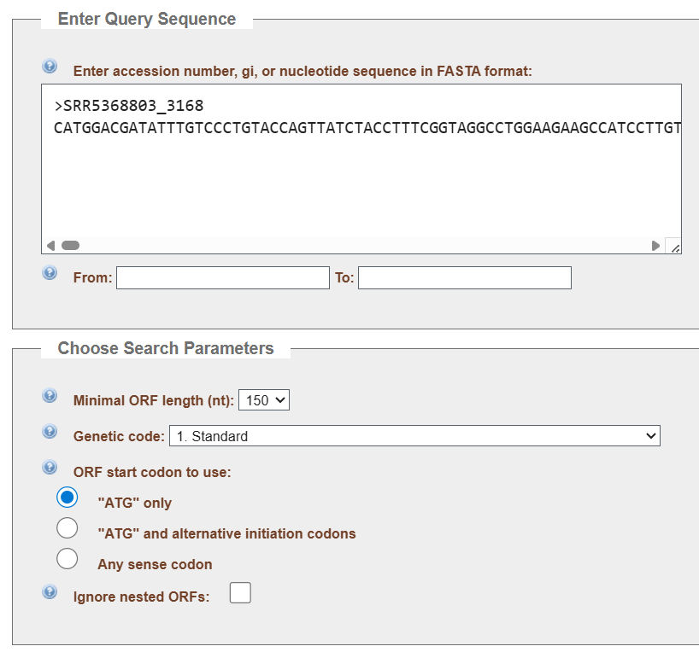
Results for ORF finder
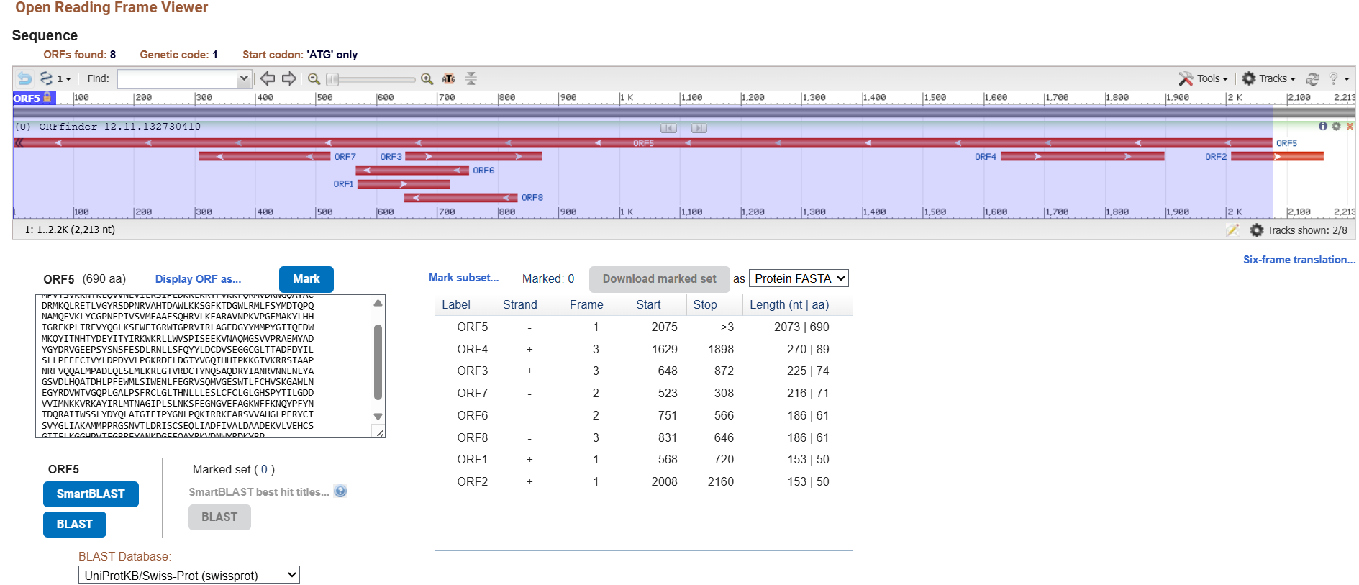
>lcl|ORF5
MPVTSVKKNTKLQVVNEVILRSIPLDKRLKRYFVKKFQRMVDRNGQAYAC
DRMKQLRETLVGYRSDPNRVAHTDAWLKKSGFKTDGWLRMLFSYMDTQPQ
NAMQFVKLYCGPNEPIVSVMEAAESQHRVLKEARAVNPKVPGFMAKYLHH
IGREKPLTREVYQGLKSFWETGRWTGPRVIRLAGEDGYYMMPYGITQFDW
MKQYITNHTYDEYITYIRKWKRLLWVSPISEEKVNAQMGSVVPRAEMYAD
YGYDRVGEEPSYSNSFESDLRNLLSFQYYLDCDVSEGGCGLTTADFDYIL
SLLPEEFCIVYLDPDYVLPGKRDFLDGTYVGQIHHIPKKGTVKRRSIAAP
NRFVQQALMPADLQLSEMLKRLGTVRDCTYNQSAQDRYIANRVNNENLYA
GSVDLHQATDHLPFEWMLSIWENLFEGRVSQMVGESWTLFCHVSKGAWLN
EGYRDVWTVGQPLGALPSFRCLGLTHNLLLESLCFCLGLGHSPYTILGDD
VVIMNKKVRKAYIRLMTNAGIPLSLNKSFEGNGVEFAGKWFFKNQYPFYN
TDQRAITWSSLYDYQLATGIFIPYGNLPQKIRRKFARSVVAHGLPERYCT
SVYGLIAKAMMPPRGSNVTLDRISCSEQLIADFIVALDAADEKVLVEHCS
GITFLKGGHPVTFGRREYANKDGFFQAYRKVDNWYRDKYRP

Open reading frame (ORF) prediction was performed on contig SRR5368803_3168 using NCBI ORFfinder with the Standard Genetic Code, a minimum ORF length threshold of 150 nucleotides, ATG-only initiation, and nested ORFs excluded. Under these conditions, ORFfinder identified eight putative ORFs distributed across both DNA strands and multiple reading frames. These ORFs varied substantially in length and positional arrangement, with several occupying short genomic intervals and encoding proteins significantly below the size expected for a functional viral RNA-dependent RNA polymerase (RdRp). Most of these smaller ORFs lacked any recognizable polymerase hallmarks and were therefore interpreted as either incidental short peptides, background assembly fragments, or non-viral open reading frames typical of metagenomic assemblies.
Among the eight ORFs, ORF5 was uniquely distinguished by both its length and its sequence content. ORF5 spans approximately 2.9 kb, corresponding to a predicted protein of 690 amino acids, placing it squarely within the size range characteristic of complete RdRp proteins in lenarviral, narnavirus-like, or mitovirus-like RNA viruses. Crucially, ORF5 was the only ORF whose amino-acid translation contained the exact 103-aa RdRp palmprint sequence previously identified from the Serratus palmprint assignment (PalmID u78967). This palmprint region (GSVDLHQATDHL…GDDVVI) appears intact and centrally positioned within the ORF, consistent with the structural layout of conserved polymerase motifs A, B, and C. The presence of this conserved catalytic core firmly establishes ORF5 as the bona fide RdRp ORF for the virus, while the remaining seven ORFs represent secondary, truncated, or nonfunctional features without direct roles in viral replication.
Together, these observations confirm that ORF5 encodes the central viral replicase and represents the primary locus for downstream functional annotation, BLASTp classification, and phylogenetic placement. All other ORFs detected in the contig were excluded from further consideration due to insufficient length, lack of palmprint inclusion, or absence of polymerase-associated motifs.

